SIMILAR SHAPES
Pearson Edexcel – Thursday 4 June 2020 - Paper 2 (Calculator) Higher Tier
1.
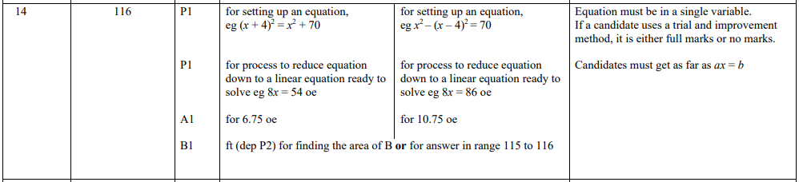
Pearson Edexcel - Tuesday 21 May 2019 - Paper 1 (Non-Calculator) Higher Tier
2.
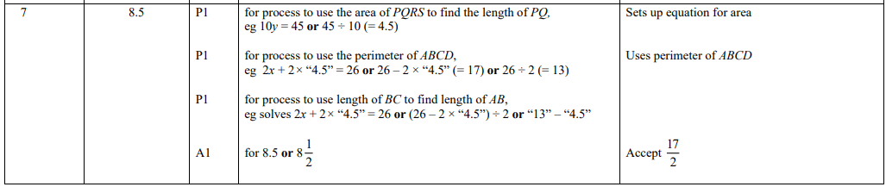
Pearson Edexcel - Tuesday 12 June 2018 - Paper 3 (Calculator) Higher Tier
3.
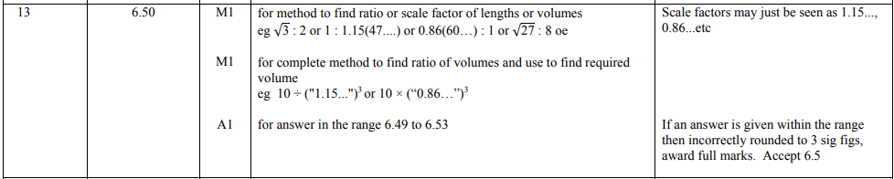
Pearson Edexcel - Wednesday 4 November 2015 - Paper 1 (Non-Calculator) Higher Tier
4.
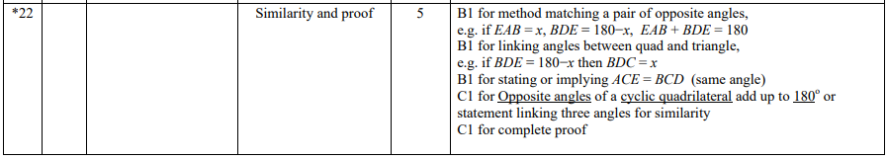

Pearson Edexcel - Monday 9 June 2014 - Paper 1 (Non-Calculator) Higher Tier
5.
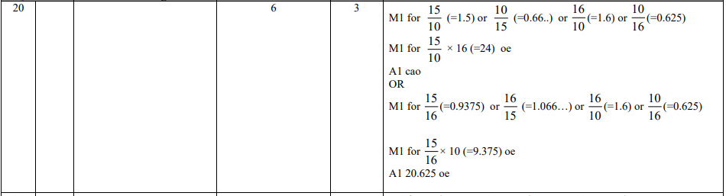
Pearson Edexcel - Wednesday 6 November 2013 - Paper 1 (Non-Calculator) Higher Tier
6.
OCR GSCE – Thursday 6 June 2019 – Paper 5 (Non-Calculator) Higher Tier
7.
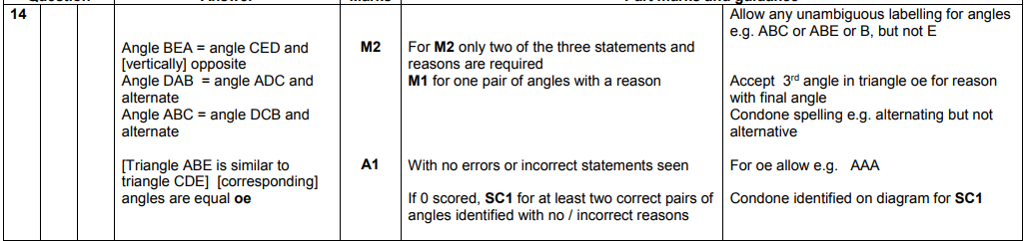
OCR GSCE – Tuesday 11 June 2019 – Paper 6 (Calculator) Higher Tier
8.
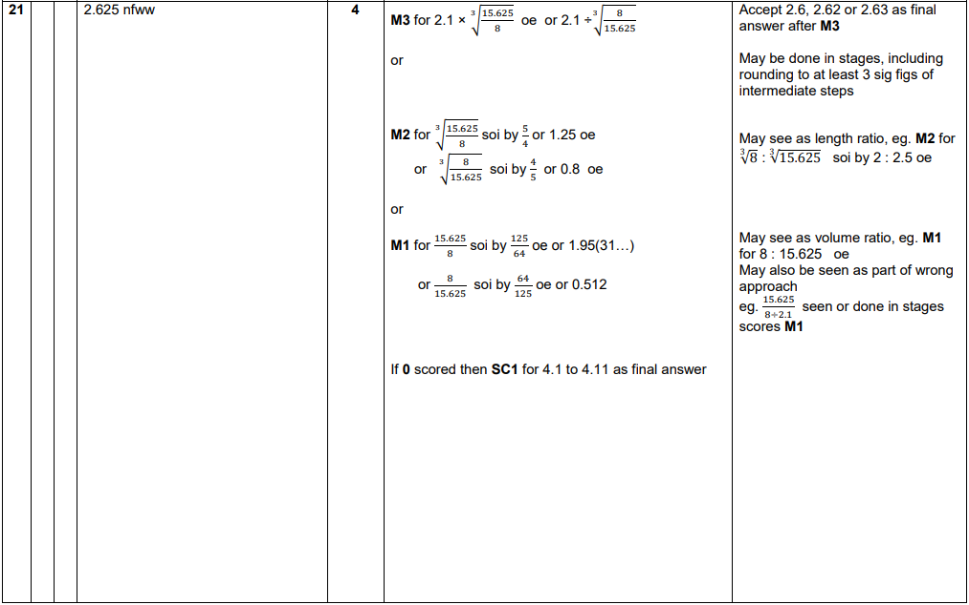
OCR GSCE – Tuesday 12 June 2018 – Paper 6 (Calculator) Higher Tier
9.
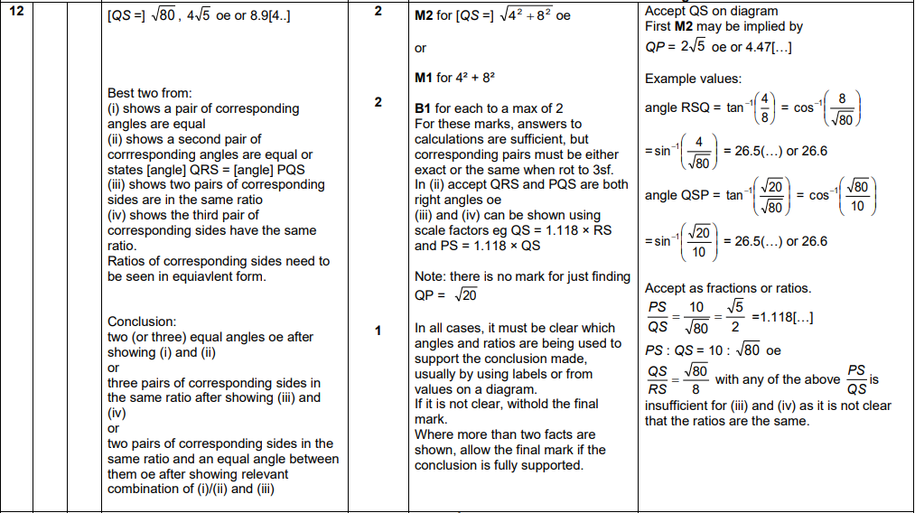

OCR GSCE – Sample Papers – Paper 6 (Calculator) Higher Tier
10.
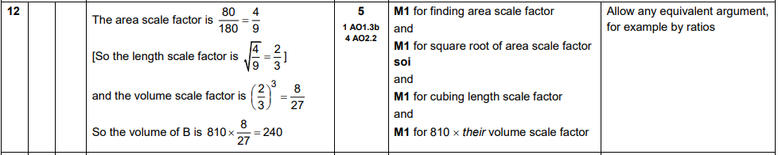
AQA GSCE – Tuesday 19 May 2020 – Paper 1 (Non - Calculator) Higher Tier
11.
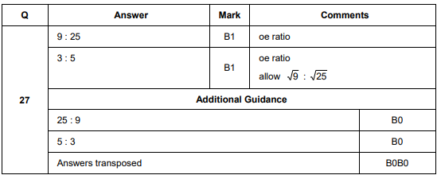
AQA GSCE – Thursday 8 June 2020 – Paper 3 (Calculator) Higher Tier
12.
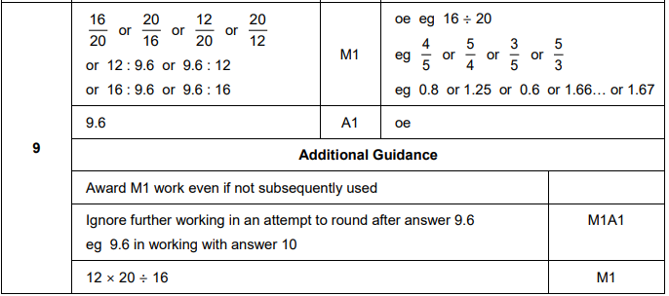

AQA GSCE – Thursday 6 June 2019 – Paper 2 (Calculator) Higher Tier
13.
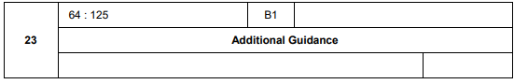
AQA GSCE – Wednesday 25 May 2017 – Paper 1 (Non - Calculator) Higher Tier
14.
AQA GSCE – Sample Paper 2 (Calculator) Higher Tier
15.
